

SECR1013 - 02 DIGITAL LOGIC

Semester/Section 2019/2020/2 Mini Project – Xerox Machine

Lecturer: Dr. Mohd Fo’ad Rohani

|  |  |
| --- | --- |
| Group Member | Matric Number |
| Simon Chong Kai Yuen | A19EC3028 |
| Chen Zhun Siang | B19EC3005 |

**Dedication & Acknowledgement**

First, we have finished the final project of Digital Logic ---Xerox machine with the dedication to our lecturer, Dr. Mohd Fo’ad Rohani and we would like to express our gratitude towards him. He spent much more time to have an online class during MCO, he was keeping conducting an online class even though it is a challenging lecture method that he had never done before. At the same time, he also did a tutorial video for each chapter for us to do revision. He patiently answered our question and solved our problem such as project, lab, or exercises. He is trying his best to help us out during the COVID-19 pandemic as we cannot present ourselves in the class, everything is conducting as online and there is no face-to-face lecture. Usually, we use Webex and WhatsApp to communicate and contact each other during the MCO period.

Finally, I would like to thank to my course mate, friends and group member who helped us in this final project. We shared knowledge and information with each other and discussed how to make it became more efficiently. We also shared our opinions and ideas with each other to modify the Xerox Machine in this project for building up a user friendly and functioning well machine.

**Table of content**

Objective 1

Materials 1

Background 1

Problem 2

Proposed solution 2

Components and Requirements 3

System implementation 5

Conclusion 9

References 9

Appendix 10

# Objective

The objectives of this laboratory are to introduce the students to:

1. Understand how the logic circuit works.
2. Learn what is the function between different hardware.
3. How to apply the simulation in Deeds-DcS Digital circuit.

# Materials

The materials of this project are:

1. Deeds-DcS Digital circuit (2.30.041 version)
2. Handouts:
   1. Digital Logic textbook (fifth edition)
   2. Digital Laboratory Manual (fifth edition)

# Background

In this project, we will implement several components in deeds.

These components including:

1. 4-bit Decoder
2. 4-bit Count up Counter (J-K Flip-Flop)
3. 4-bit Comparator (XNOR gate)
4. Clock Disabler (AND gate)

# Problem

User will initially enter amount of copies, the counter will count the number of copies that has been photocopied. The machine will be terminated once the required number of copies has been produced.

# Proposed solution

The circuit block diagram of a component required is shown in Figure 1 below. Firstly, user is required to switch on the power button on the circuit. Then user is now required to enter 4 digit of password, 4 bits for each digit of number, so there is 16 bits that user must input (totally 65536 combination/possibilities), there is a very strong security on it. This is to prevent unauthorised usage of the machine. If the entered password is incorrect, the user cannot proceed to next step. Once the entered password is correct/valid, the LED “HELLO” will light up and keep blinking to indicate that the machine is now ready to use.

Next, user is required to select properties of the printing. These properties are colour or black and white printing, paper size, zoom ration and last is allow user to choose local or network printer. In this part, we used 2-1 multiplexer and demultiplexer, and 4-1 multiplexer and demultiplexer, Multiplexer is use to let user select the properties and a demultiplexer is use to indicate the choice that the user had chosen and the 7-segment display will be triggered and user can also see the selected number from the LED array. There are three core components that is required in this Xerox machine which are 4-bit comparator, 4-bit JK positive edge count-up counter and a clock disabler. User is required to input the number of copies (maximum 15 copies due to 4-bit, 1-F input in this case) and press the CLR button to start printing. The counter is used to count the number of printed copies currently. Thus, the comparator will compare the number of required copies and the number of printed copies, once the number of required copies is equal to the number printed copies, the clock disabler will be triggered to terminate the counter from counting up. If the amount of them are different, the counter will keep counting up until they have the same value to finish the photostat process.

Lastly, to implement this system completely, we set the PRESET button is equal to 1 as default. So, when user need to reset the number of copies, they just need to press the CLR button to reset it to 0. There are two 7-segment display are connected to this circuit, one is connected to the required copies and another one is connected to the printed copies to display the current amount, respectively.

|  |
| --- |
|  |
| Figure 1: A block diagram of a complete system |

# Components and Requirements

1. 4-16-bit decoder
   * To check the password condition whether it is correct.
   * A part of security in this system, if it is wrong, user is not allowed to use the system.
   * 4-bit x 4 = 16 bits password is required to enter, 65536 combinations/possibilities.
2. LED array
   * To display the current activated output.
   * To see the difference of each output, only 1 output is selected at once.
3. Multiplexer
   * Allow user to select the printing properties.
4. Demultiplexer
   * To display which properties is selected.
   * Determine local or network printer.
5. Input Dip-switches & Hex-digit
   * To set the initial amount of copies that user want to print.
6. 4-bit positive count-up counter (JK flip-flop)
   * To count the currently amount of printed copies.
7. 4-bit comparator
   * To check and compare the number of current printed copies and required copies.
8. Clock disabler (AND gate)
   * To terminate the counter if the number of current printed copies is equal to required copies.
9. 7 segment display
   * To display the number of required copies and printed copies.

# System implementation

1. Decoder

We use four 4-bit decoder to decode the set of binary passwords. The enable pin of 4-bit decoder is connected to power button by which mean the decoder will only activate when the power button is activate. The output of the decoder is connected to a “HELLO” LED. Once the LED blinking, means the password is correct it allows the photocopy machine to start working. The output of decoder is connected to multiplexer, means to activate the properties selection state, the password must be correct.

1. LED array

To display which output is selected, there is only one output at once.

1. Multiplexer

Multiplexer is used to allow the user to choose the printing properties that the user wants. User input S0 and S1 to choose the properties that the user need. For colour mode, when S0=0, the user will select the black and white printing, while S0=1 the user will select colour printing. In paper size properties, when S1=0 and S2=0, S1=0 and S2=1, S1=1 and S2=0, S1=1 and S2=1, means user choose A5, A4, A3 and A2, respectively. While in zoom mode, S1=0 and S2=0, S1=0 and S2=1, S1=1 and S2=0, S1=1 and S2=1, means user choose 100%, 125%, 150% and 200%, respectively. Other than that, user can choose either local printer or network printer, this will involve a demultiplexer to choose between these two choices, when S=0 and S=1, means local printer and network printer, respectively. Right area is local printer while left are is network printer. All these multiplexers are connected to four 4-bit decoder, if the user enter an invalid password then it cannot proceed to this step.

1. Demultiplexer

Demultiplexer are connect to output of multiplexer thus this component is used to determine the properties that the user had chosen.

1. Input Switch

There is 1 switch that controlling 4 bit for the user to input the number of copies they required. Each of the rows represent a single bit, which are A0, A1, A2 and A3, respectively. They have their own bit which are 1, 2, 4 and 8. Hence, the user can input value ranging from 0 to 15 only (16-bit). The output of input switch is connected to a 7-segment display and comparator.

1. 4-bit positive count-up Counter (J-K flip-flop)

The counter that we used in the project is 4-bit J-K positive edge count-up counter. The counter starts to count based on the clock disabler, it will start counting if the J and K input are connected to high input. In our case we used combination of properties as the active high input, once the password entered is correct and the clock disabler is being active. It will stop when the clock pulse is no longer received or reached the number of counts initialised by the user.

|  |
| --- |
| CE = Clock disabler |
| Figure 2: State diagram of JK-flip-flop |

1. 4-bit Comparator

The comparator is built by four 2-input XNOR gates to compare value from 2 sources, which are the input switches and the counter output Q. The first XNOR gate compare the least significant bit (LSB) of the 2 sources (input and Q). If they are same, the output will be 0 and it is sent to the NOT gate and convert it into 1. The same principle applies for the second, third and fourth XNOR gate. Then the signal from all the four gates will be sent to a NAND gate to convert it into opposite signal. Therefore, when all the XNOR gate received the same input from input switches and the counter, it will send a signal 0 to clock disabler to terminate the photocopying machine.

1. Clock disabler

The clock disabler is set up by using a 2-input AND gate. The input of the AND gate is the clock source and a signal sent by the comparator. The disabler can only be active when all two inputs are high/1. It used to stop the operation of the counter when the amount of copies and printed copies are equal.

1. 7-Segment display

This component displays the number by converting the binary code received and into hexadecimal. Two 7-segment displays are used where one of them shows the number of required copies and the another one shows number of current printed copies.

|  |
| --- |
|  |
| Figure 3: The completed system in deeds |
|  |

# Conclusion

In a nutshell, we successfully completed the project. We able to propose a solution based on the problem that we figure out and the circuit can function well. Is a fact that, real xerox machine has a more complex circuit design inside it, but this project increases our knowledge on how does the xerox machine work and the simple circuit inside it. Now we know that the main design of xerox machine are consist of decoder, counter, comparator, and clock disable. Due to the COVID-19 pandemic, we can only practice this lab in simulation by using deeds. After finished this project, we learnt and gained knowledge about simulating circuit project in deeds. Although we know the theory but if we lack on practical, we are still not able to conduct a complete circuit. We encountered some problems but fortunately, we managed to solve these problems. We also gained a lot of experience from this project.

# References

* DL lab 4 in SCSR 1013- Digital logic. (n.d.). MyePortfolio@UTM. <https://eportfolio.utm.my/artefact/artefact.php?view=128053&artefact=576033>
* Asynchronous counter: Definition, working, truth table & design. (n.d.). <https://circuitdigest.com/tutorial/asynchronous-counter>
* Magnitude comparator in digital logic. (2019, November 25). GeeksforGeeks. <https://www.geeksforgeeks.org/magnitude-comparator-in-digital-logic/>

# Appendix

**1.)** **Deeds** **Simulation**

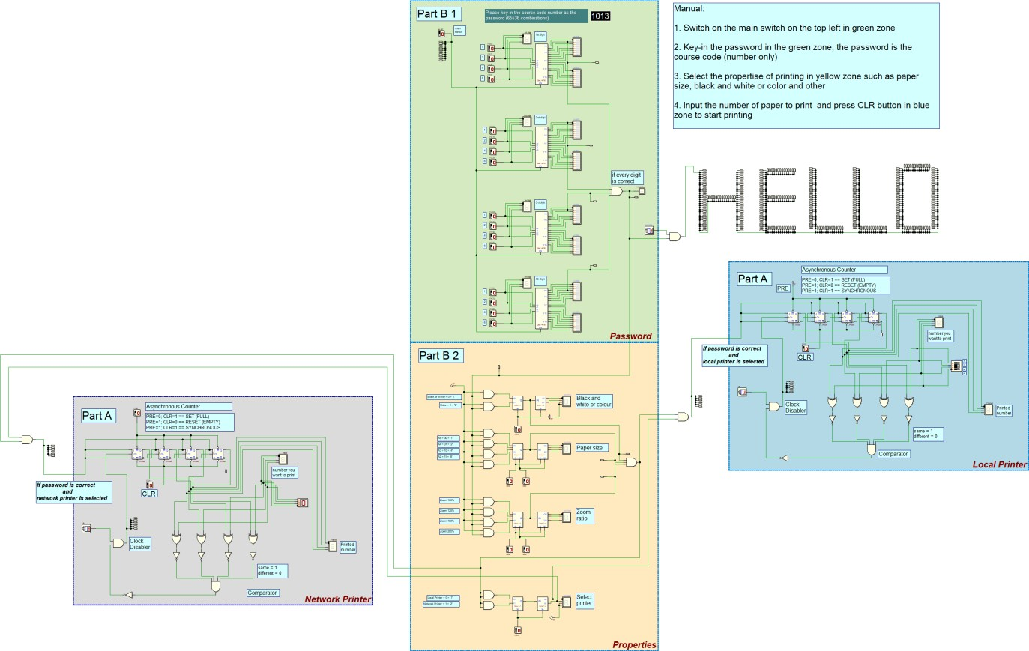

**2.) Task Involvement**



